**Sachin Chaudhary  
230701402  
EX NO. 8a:**

**Low fidelity paper prototypes for a banking app using pencil project  
 Diagram**

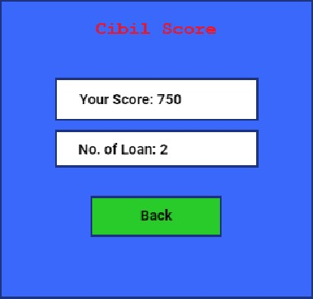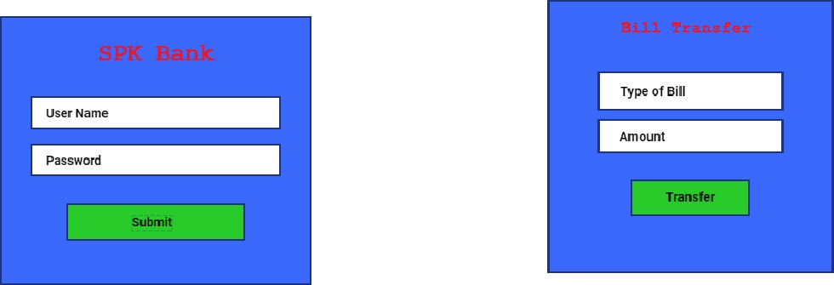

|  |  |  |  |  |  |  |  |  |  |  |  |  |  |  |  |  |  |  |
| --- | --- | --- | --- | --- | --- | --- | --- | --- | --- | --- | --- | --- | --- | --- | --- | --- | --- | --- |
| |  |  |  |  |  | | --- | --- | --- | --- | --- | |  |  |  | |  | | Balance  Transfer |  |  | History    Score    Logout | | | Bill payment |  |  | |  |  |  | | |  |

